1.Select \* from salgrade;

2.select deptno from dept;

3. select (sal+sal\*0.05) "5% Increment" from emp;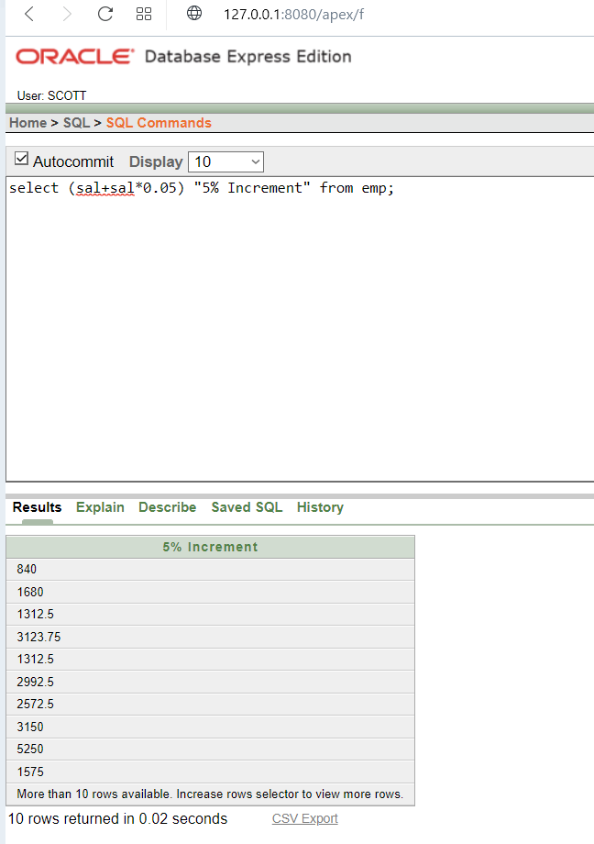

4.select ename,sal,(sal+sal\*0.05) "5% Increment" from emp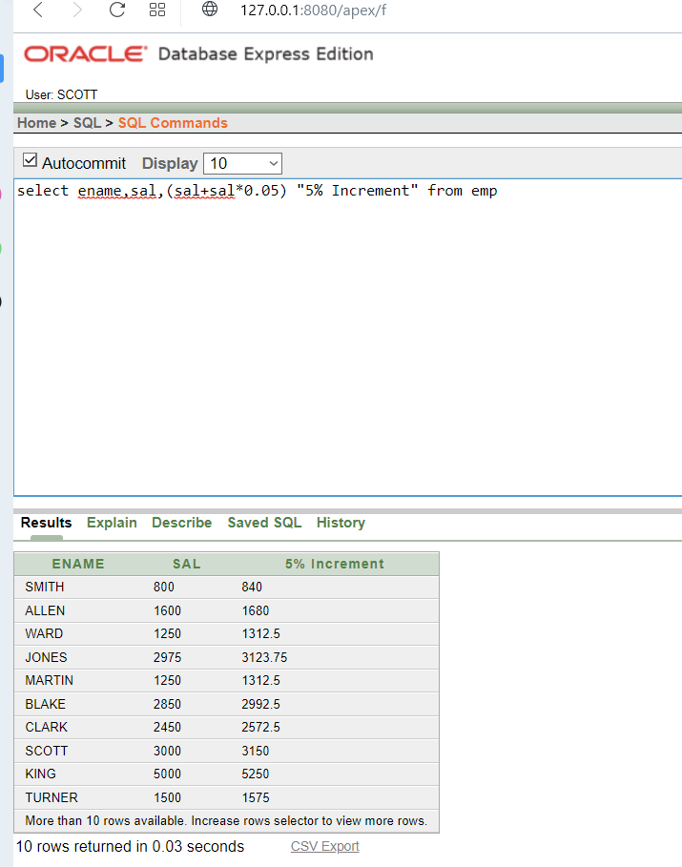

5.select \* from emp where ename = “BLACK”

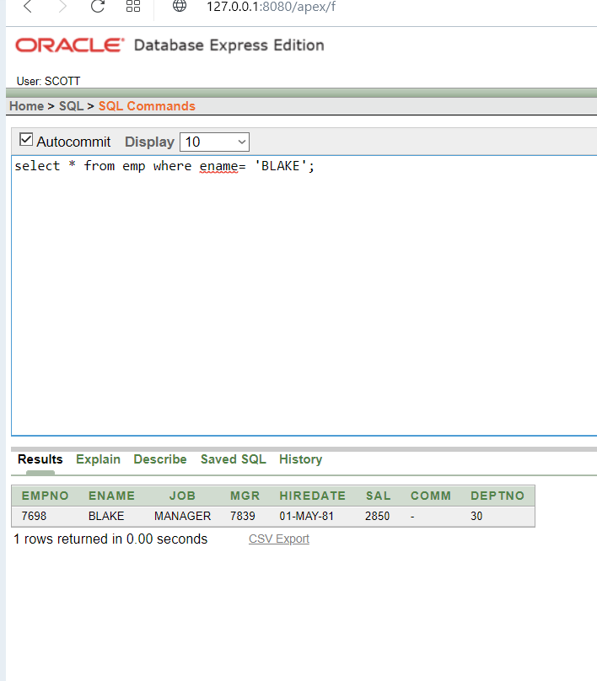

6. select ename|| 'is hired on' ||hiredate||' as a '||job "Description" from emp where hiredate between '17-dec-80' and '28-sep-81';

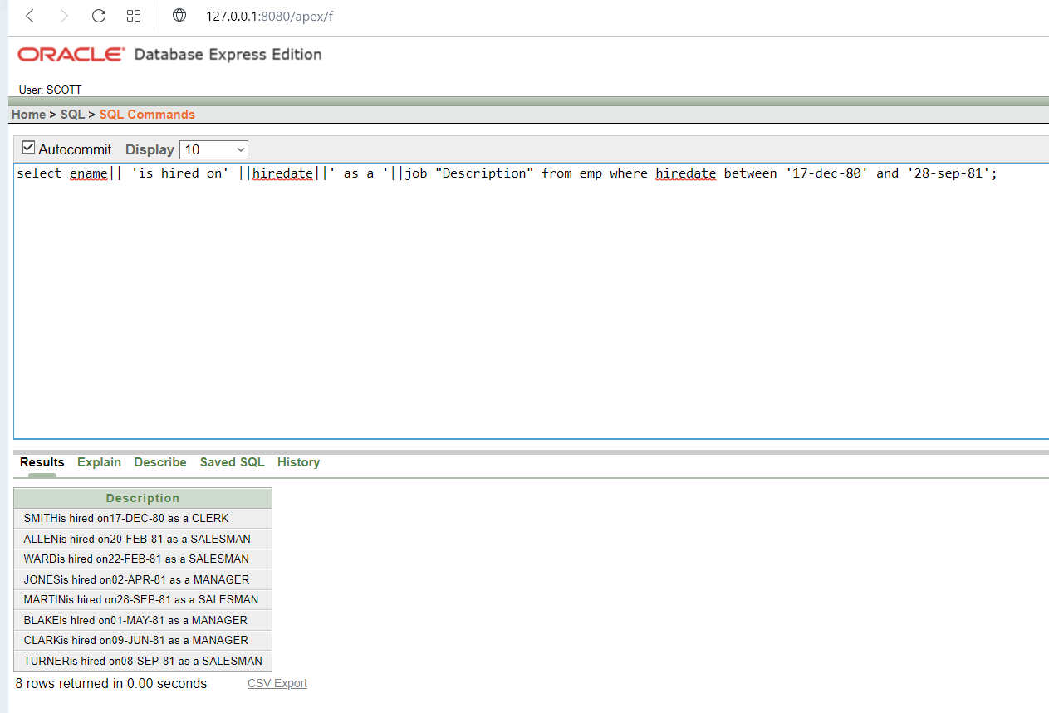

describe bonus;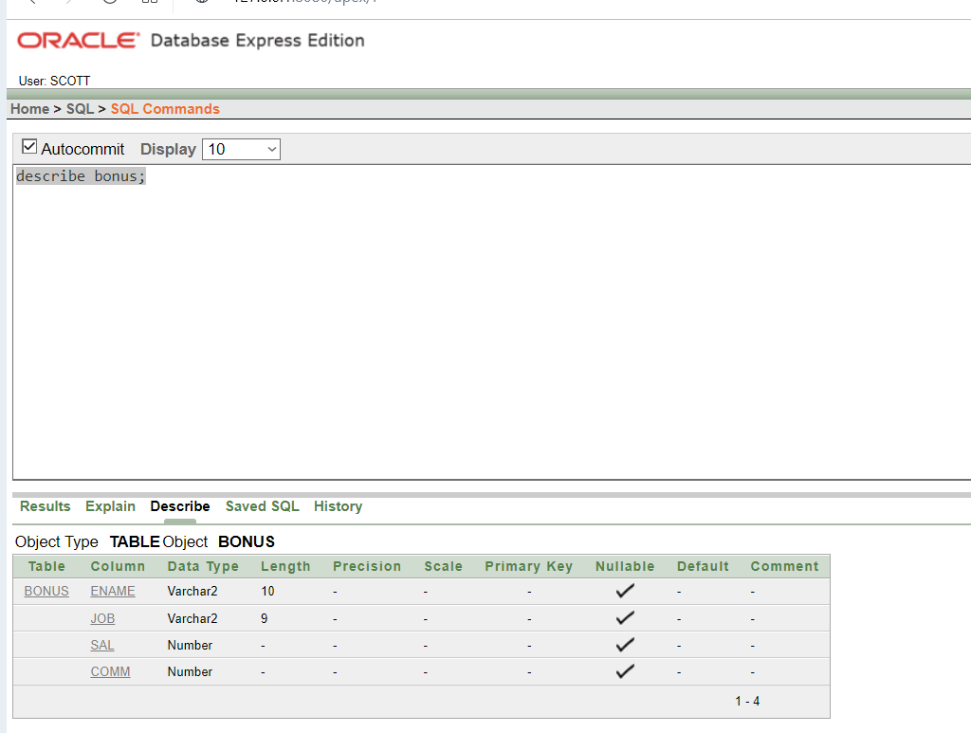

describe dept;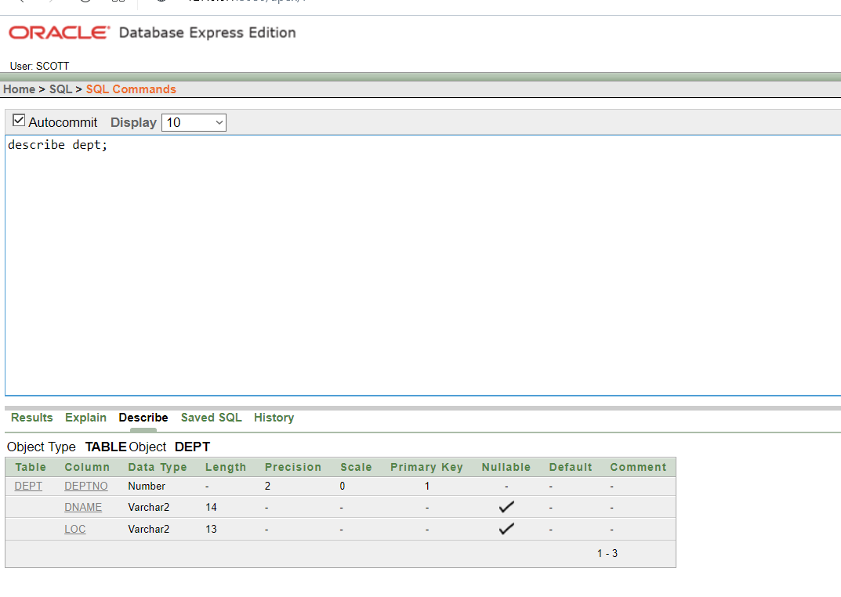

8. select distinct job from emp;

